Fire Triangle Lesson Plan (2 of 6)

Author: Brittany Ciancarelli; Modified from “Investigating Fire Ecology in Ponderosa Pine Forests: A Field Guide for Sixth Grade Teachers” Published by the NPS Parks as Classrooms program. www.nps.gov/band.

Subject/Class: Science

Grade Level: 7th Grade

Standards: Aligned to Arizona State Science Standards (Grade 7)
http://www.azed.gov/standards-practices/science-standard/
-Grade 7, Strand 3, Concept 1, and Strand4, Concept 3: How can we interact better with our environment?
-C4PO5: Predict how environmental factors affect survival rates in living organisms.

Goals: SWBAT create a model describing the 3 essential elements of the flame, wildfire, and fire regime triangles.

Learning Objectives:
1. SWBAT recall familiar burnable fuels.
2. SWBAT write down my observations of the candle demonstration concerning fuel, oxygen, and heat.
3. SWBAT list the sources of heat and fuels for flames/wildfires.
4. SWBAT create a model describing the 3 essential elements of the flame, wildfire, and fire regime triangles.

Materials/Resources:
-Powerpoint (Fire_Ecology_Slideshow_Workshop2013.ppt, slides 16-41)
-Student Handout 1: Notetaker
-Student Handout 2: Fire Triangle Graph Image
-Student Handout 3: Ponderosa Pine Fire Ecology Article
-Student Handout 4: KWL sheet
-Candle, matches, glass to fit over candle, markers/crayons/colored pencils (pick one), rulers, popsicle sticks or 3 different size sheets of paper (so one will fit inside the other when shaped like a triangle.
* Powerpoint can be found on the website referenced in upper-right hand corner of this lesson.

Set-Up
- Make enough copies for all students of the Pre/Post Fire Survey, Student Handout 1, 2, 3, and 4.
- Set-up computer and projector to display powerpoint presentation.
- Prepare space to do fire triangle candle demonstration that is visible to all students, but safe for a few brief moments of open flame.
Procedures
Part 1: Introduction (20 minutes)
- Students will take notes on the scientists who study fire ecology. Periodically check for understanding using a variety of interactive participation methods such as discussion, think/pair/share, or answer cards.
- Discuss with students what is needed for fire? Why aren’t burnable things on fire at any given time? What fuel in fire are we familiar with? Have students come up with their own ideas of what is needed for fire and then as a class organize those ideas into the fire triangle.
Part 2: Fire Triangle Activity (10 minutes)
- Have students observe the candle demonstration and record which part of the fire triangle is missing on their lab sheets.
- Using the candle, demonstrate that if any of the three sides of the fire triangle is broken, then there is no fire.
- Stare at the candle for a moment. Ask why it is not burning? What is missing from the fire triangle? (Heat)
- Light the candle. Place the jar over the candle. Wait until the candle goes out. Ask why the candle is no longer burning. What is missing from the triangle? (Oxygen)
- Light the candle again. Use scissors to cut the wick. What is missing from the fire triangle? (Fuel)
Part 3: Fire Triangle Notes (15 minutes)
- Notetaking on fire triangles. Show Fire triangle graph after the notetaking is done. Instruct the students that these 3 fire triangles represent fire as small as a flame to as large as a fire regime, which encompasses a large amount of space and a pattern of fire occurrence over time.
Part 3: Ponderosa Pine Reading and Creating Fire Triangle Activity (35 minutes)
- Pass out the Ponderosa Pine Fire Ecology reading and the KWL sheet to the students. Have students answer the following questions. What role does fire play in the Ponderosa Pine forest? What were wildfires like before 19990? What have the wildfires been like after 1990? How has the fire regime changed? Have students discuss their answers with their partners before sharing with the class.
- Have students use popsicle sticks or paper to create their fire triangles. They must make their triangles and then describe the three essential parts.
Student Handout 1: Notes-taker

Ponderosa Pine Ecosystems and Forest Fires

A. What people study forest fires?

1. Fire Ecologists-

2. Dendrochronologists-

3. How do Dendrochronologists study fire?

4. Archaeologists-

5. How do archaeologists study fire?

6. Climatologists-

7. How do climatologists study fire?

B. Weather vs. Climate

8. What is weather?

9. What is climate?

C. Healthy Ponderosa Pine Forest

10. What does a healthy ponderosa pine forest look like?

11. What does an unhealthy ponderosa pine forest look like?

D. The essential elements of fire

12. Small scale: seconds (ie. camp fire or candle)

-

-

-

13. Medium scale: recurring fire for days (forest fire)

-

-

-

14. Large scale: recurring fire over decades (fire regime)

-

-

-

15. What is a fire regime?

Student Handout 2: Fire Triangle Graph Image

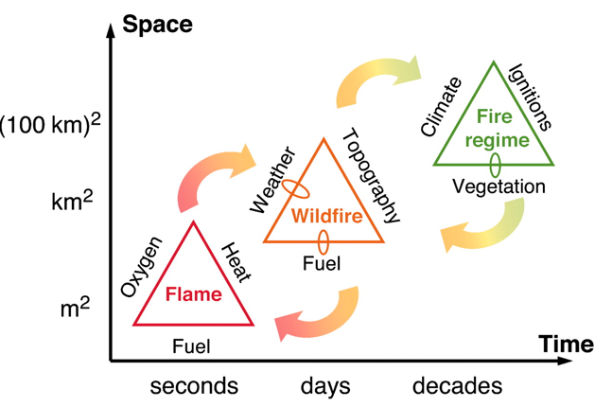

Student Handout 3: Ponderosa Pine Fire Ecology Article

Ponderosa Pine Fire Ecology

Author: Will Moir, USFS Rocky Mountain Research Station, Flagstaff, Arizona.
Open Ponderosa Pine Forest

The ponderosa pine forests of the Colorado Plateau have evolved over thousands of years. Over this time the tree has developed several adaptations which help it survive in its dry, often warm habitat. A once common occurrence in these forests which has shaped the pine's particular ecological adaptations is wildfire. Recent studies indicate that the ponderosa pine forests on the southern plateau near Flagstaff, Arizona and along the Mogollon Rim were subjected to low-intensity ground fires perhaps every 2-12 years over historical time. However, beginning in the early 1900s this pattern of fire drastically changed. A fire suppression policy implemented by the United States Forest Service and other land management agencies at this time greatly decreased the occurrence of fire in these forests. The absence of reoccurring fire, coupled with widespread logging and grazing of forest lands, has led to unforeseen changes in forest composition, structure and ecology.

Today's forest is often characterized by dense "dog-hair" thickets of young pines with a thick accumulation of litter on the forest floor. Previously, many pine forests of the region were open stands of large, old ponderosa pine underlain by an understory of native grasses. Small fires maintained this open structure by killing seedlings and encouraging growth of grasses. Some ecologists recognized this change in the nature of these pine forests as a possible problem as early as the 1930s, but changes in forest management did not occur until the 1970s. Fires in many of today's ponderosa pine forests are no longer low-intensity ground fires but rather catastrophic, stand-replacing crown fires.

From about 1910 to approximately 1990, the amount of acres burned by wildfire in Arizona and New Mexico oscillated between a few thousand acres to 60,000 acres annually. This yearly amount is dependent on local factors such as weather and fuel loads on the forest floor. However, beginning in 1992 the amount of acres burned between the two states has skyrocketed, with over 180,000 acres burning in 1997. Prior to fire suppression, the fires in the pine forests of the region behaved in a somewhat predictable manner determined by years of evolution and natural processes. The forest ecosystem of today, in contrast, has possibly reached a point of instability. A lightning strike may lead to a few trees burning, a few acres burning, or a catastrophic stand-replacing fire sweeping over thousands of acres of forest. Land managers and scientists are no longer able to predict with much confidence what direction fires in the ponderosa pine forests of the Colorado Plateau and the whole Southwest might take.
High severity wildfire

Fire control personnel with the United States Forest Service and other land management agencies are concerned that more fires might be dangerous, catastrophic fires until fuel loads are reduced below the critical threshold. Extensive tree-thinning projects and prescribed burning are two steps forest managers are taking to try to decrease the danger of high-intensity fires as well as restore the ponderosa pine forests of the region to a more "natural" state.

Despite the bleak appearance of charred black sticks following a major crown fire, native organisms and plants often quickly invade the site and recovery is underway. However, in many areas following these burns invasive species are able to establish themselves, crowding out native species.

Student Handout 4: KWL Sheet

K:What do you know?

W: What do you want to know?

L:What you learned?

